Name _________________________ Period _____
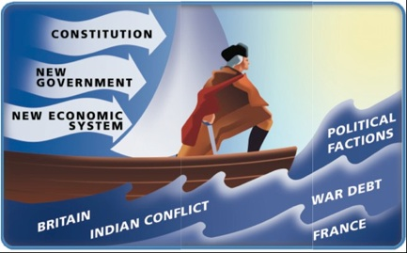
Ch. 7: Launching the Nation

Before we begin…
In what year was the U.S. Constitution ratified?

Timeline questions (pp.230-231)
- When did Washington become the first U.S. president?

- What other event began that same year?

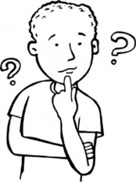
- Who was elected as the second president of the U.S. in 1796?

Thought Question:
- If you were one of the framers of the new government at that time, what might your first actions have been?

Section 1:
Defining Key Terms & People:
- precedent:

- Judiciary Act of 1789:

- Why did Americans select George Washington as their first president?

- How do you think a modern cabinet meeting might look different from the one shown on page 235? (Give two ways.)

- What precedent did President Washington and Congress establish regarding the executive branch?

- Which city served as the first capital of the United States? Explain why this location was chosen.

- What expectations did most Americans have for the new nation?

- Do you think New York City should still be the capital city of the U.S.? Explain your answer.

Section 2:
Defining Key Terms & People
- Alexander Hamilton:

- National debt:

- Thomas Jefferson:

- Loose construction:

- Strict construction:

- What economic problem did the young nation face?

- How did Alexander Hamilton propose to solve the problem above?

- How did southerners feel about the federal government paying state war debts, and how did Hamilton change their minds?

- What were the main differences between Hamilton and Jefferson concerning the power of the nation’s government?
Hamilton:

Jefferson:

- What did Hamilton think a strong central government should do?

- How did Jefferson’s and Hamilton’s views on how to promote economic ($) growth differ?

- What was the function of the Bank of the United States?

- Defend Hamilton’s stance in favor of the creation of a national bank. (Explain his point of view.)

- Do you agree with loose construction or strict construction of the Constitution? Explain why.

- What compromise did Hamilton, Jefferson, and Madison reach regarding repayment of state debts?

- Do you agree with Hamilton or Jefferson regarding the average citizen’s ability to make decisions for the country? Explain your answer.

Section 3:
- Why did Native Americans in the northwest go to war in the early 1790s, and who was their leader?

- How did the Congressional tax on American-made whiskey lead to the Whiskey Rebellion?

- Why was it significant that President Washington personally led the army against westerners in the Whiskey Rebellion? (What message did it send?)

- What two main warnings did Washington give the nation in his Farewell Address?

- Why did Washington suggest neutrality as a foreign policy?

Section 4:
Key Terms & People:
- Political parties:

- Federalist Party:

- Democratic-Republican Party:

- XYZ affair:

- Alien and Sedition Acts:

- Kentucky and Virginia Resolutions:

- Why was the election of 1796 different from the previous election?

- What role did geography (example: location) play in where you might find supporters of the two new political parties?

- What did American’s mean when they said, “Millions for defense, but not one cent for tribute”?

- Why was it difficult for Adams and Jefferson to serve together as president and vice president?

- What was one of Adams’s first goals as president?

- How did the Kentucky and Virginia Resolutions support the rights of states?

